**Screenshot log for Hypotheses**

**Hypothesis 1**

Breakpoint set in CheckoutCTL Line 67

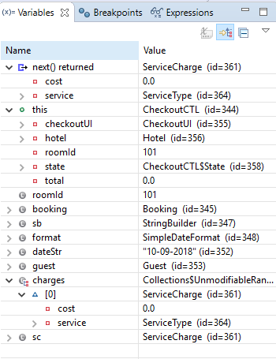

**Hypothesis 2**

Breakpoint set in RecordServiceCTL Line 52

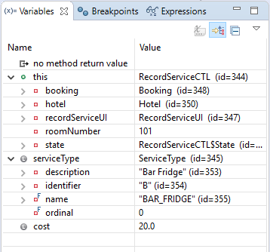

**Hypothesis 3**

Breakpoint set in Hotel Line 112

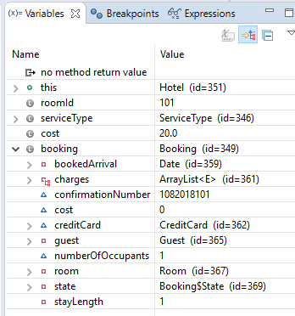

**Hypothesis 4**

Typo in Booking Line 141 – incorrect values sent to hotel

